Tornado/Covid Response Metro Food Distributions:
Weekly food distribution for families will continue on Wednesdays at
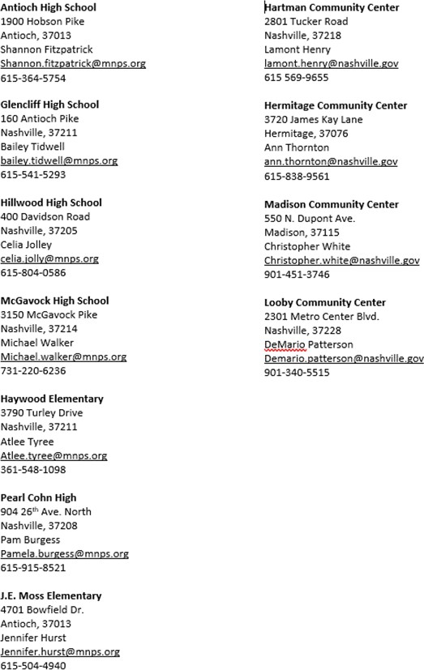
1pm at the following locations. This is open to the public. Each of these sites are serving 200-400 households each week.

